

**DEPARTMENT OF BIOTECHNOLOGY**

**Experiential Learning**

**Report on**

**Modified AES Encryption Algorithm Implementation**

**Design and Analysis of Algorithms**

(CD343AI)

2023-2024

**Submitted by**

| **Name:** | **USN:** |
| --- | --- |
| Sathwik Chandra | 1RV22CS179 |
| Sahil S Naik | 1RV22CS169 |
| Sai Varun Konda | 1RV22CS177 |
| Samarth Gothe | 1RV22CS173 |

**Under the guidance of**

Dr.. H RAJU

Assistant Professor

Department of Biotechnology

RV College of Engineering

**ACKNOWLEDGEMENT**

We would like to express our deep sense of gratitude to our respected guide H Raju, Assistant Professor, Dept. of Biotechnology, RVCE, for his valuable help and guidance, and are thankful for the encouragement given to us in completing this Experiential Learning. We are also grateful to Dr. Ramakanth Kumar P, Head of Department, Dept. of CSE, RVCE for permitting us to utilize the facilities of the department for research and implementation of our project. We are also grateful to our respected Principal, Dr. K N Subramanya. Lastly, we would like to thank our classmates and our parents for providing us with moral support and encouragement.

**ABSTRACT**

This report provides a comprehensive analysis of Lay’s American Style Cream and Onion flavor in India, focusing on material analysis, process optimization, administrative development, and service innovation. It begins with a detailed examination of the raw materials, including potatoes, onion powder, cream powder, vegetable oils, spices, acidity regulators, and preservatives, highlighting their sourcing, quality, and compliance with Indian regulatory standards. The process analysis section explores Lay’s streamlined manufacturing techniques and supply chain synergies, emphasizing the company's commitment to operational efficiency and sustainability. Administrative development at Lay’s is showcased through its strategic use of lean management principles, data-driven decision-making, and continuous investment in research and development to drive product innovation and packaging sustainability. Lastly, the service development segment underscores Lay’s approach to consumer engagement and market responsiveness, highlighting its collaborative R&D efforts, agile product development processes, and focus on healthier, eco-friendly snack options. This report underscores how Lay’s integrates these elements to maintain its competitive edge and ensure consumer satisfaction in a dynamic market.

**CONTENTS**

1. INTRODUCTION……………………………………………….05
2. RAW MATERIALS……………………………………………...05
   1. SOURCING PRACTICES………………..05
   2. NUTRITIONAL FACTS………………….08
3. PROCESS DEVELOPMENT……………………………………09
   1. POTATO SOURCING AND PREPARATION…….09
   2. FRYING AND SEASONING PROCESS…………09
   3. PACKAGING AND DISTRIBUTION……………10
4. ADMINISTRATIVE DEVELOPMENT………………………...10
   1. STREAMLINED PROCESSES…………………..11
   2. DATA DRIVEN INSIGHTS……………………...11
   3. INNOVATION AND PRODUCT DEVELOPMENT
5. SERVICE DEVELOPMENT……………………………………12
   1. ACTIONS INVOLVED…………………………..13
   2. OPERATIONAL EFFICIENCY………………….15
   3. QUALITY ASSURANCE AND CONTROL…….15
   4. FUTURE INITIATIVE AND EXPANSION PLANS…17
6. REFERENCES…………………………………………………..18
7. **INTRODUCTION**

Lay's, a globally recognized brand of potato chips, is renowned for its diverse flavor offerings. Among these, the "American Style Cream & Onion" flavor is particularly popular in India. This report delves into the material analysis of this specific flavor, focusing on its composition, packaging, and regulatory compliance within the Indian market.

1. **Raw Materials**

Lay's, a flagship brand under PepsiCo, is a market leader in the Indian snack industry, renowned for its wide range of flavored potato chips. The American Style Cream & Onion flavor is one of its popular variants, celebrated for its rich and tangy taste profile. This section provides a comprehensive analysis of the raw materials used in the production of Lay's American Style Cream & Onion chips in India. It highlights the sourcing locations within the country and the selection criteria employed to ensure product quality, sustainability, and regulatory compliance.

* 1. **Sourcing Practices**
     1. **Potatoes**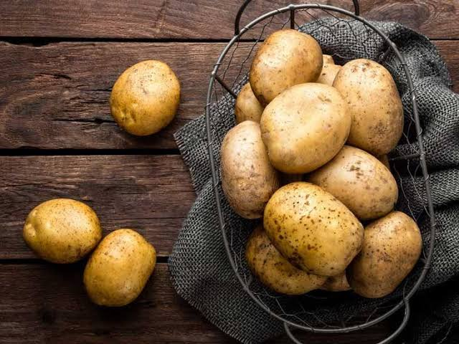

Potatoes are the primary ingredient in Lay's chips, providing the base for the product. They are selected for their ability to become crispy when fried, contributing to the signature crunch of Lay's chips. The high starch content in the chosen potato varieties ensures they fry well without becoming soggy.

Lay's sources potatoes from large-scale farms and cooperatives in Uttar Pradesh, West Bengal, Bihar, Punjab, and Karnataka. These regions are chosen for their optimal growing conditions, ensuring high starch content and low moisture levels essential for producing crispy chips.

* + 1. **Onion Powder**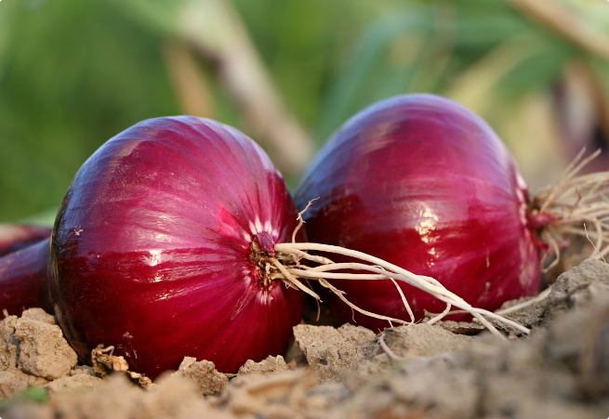

Onion powder is a key ingredient, providing the distinct onion flavor that defines this chip variety. It offers a concentrated flavor without the moisture content of fresh onions, ensuring the chips remain crisp.

Produced locally from fresh onions harvested in Maharashtra, Karnataka, and Gujarat, maintaining flavor integrity. Fresh onions are processed into powder at local facilities to preserve flavor and quality. Onions with potent flavor with minimal bitterness, low moisture content and free from impurities are chosen.

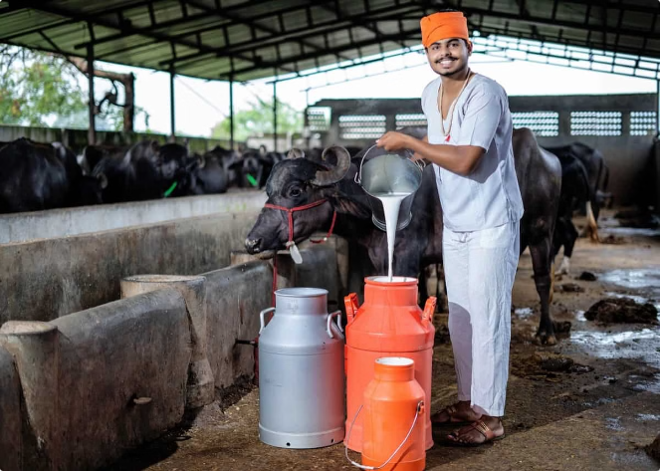

* + 1. **Cream Powder**

Cream powder is essential for providing the creamy taste and texture that characterizes the "American Style Cream & Onion" flavor. It adds richness and balances the sharpness of the onion flavor.

Sourced from major dairy-producing states such as Rajasthan and Uttar Pradesh. They are supplied from established dairy cooperatives and processing plants that ensure high-quality cream powder.

* + 1. **Vegetable Oils**

Vegetable oils are used for frying the potato chips, contributing to their texture and flavor. Palm oil is chosen for its high smoke point, making it ideal for frying at high temperatures without breaking down. Sunflower and canola oils are used for their light taste and health benefits, offering a balance between flavor and stability.

Palm oil is primarily imported from Indonesia and Malaysia and processed in Indian refineries located in Gujarat and Maharashtra. Sunflower and canola oils are sourced from local growers in Madhya Pradesh, Rajasthan, and Gujarat, ensuring fresh supply and supporting regional agriculture.

* + 1. **Spices and Condiments**

Spices and condiments, including garlic powder, salt, and sugar, are used to enhance the overall flavor profile. They add depth and complexity to the chips, making them more appealing to the Indian palate.

Sourced from spice-rich regions like Kerala and Tamil Nadu, ensuring authentic and potent spice profiles. Spices are selected on the basis of their quality, freshness, purity and consistency.

* + 1. **Acidity Regulators and Anti-caking agents**

Acidity regulators like citric acid and lactic acid are used to balance the flavors and extend the product's shelf life. They help in maintaining the chips' taste over time by preventing spoilage.

Anti-caking agents like silicon dioxide are added to the seasoning mix to prevent clumping, ensuring that the flavor is evenly distributed across the chips.

Procured from chemical suppliers in industrial hubs such as Maharashtra and Gujarat, ensuring food-grade quality and compliance with safety standards.

* + 1. **Preservatives**

Preservatives like TBHQ (Tertiary Butylhydroquinone) are used to prevent oxidation of the oils, which could lead to rancidity. This helps in maintaining the freshness and extending the shelf life of the chips.

Chemical manufacturing plants in Maharashtra, Gujarat, and Uttar Pradesh supply preservatives like TBHQ. Preservatives must adhere to FSSAI limits for preservatives in food products, have high efficacy in extending shelf life without altering flavor and must be **a**pproved for use in food products and free from harmful contaminants.

### Nutritional Facts

1. **Calories and Fat**A serving of Lay's potato chips typically contains a significant amount of calories and fat, primarily from the potatoes and oil used in the frying process.
2. **Sodium Content**Lay's potato chips are generally high in sodium due to the salt used in seasoning and the absorption of salt during frying.
3. **Carbohydrates and Fiber**Potato chips are a source of carbohydrates from the potatoes but contain a limited amount of dietary fiber.
4. **Vitamins and Minerals**While Lay's potato chips contain some vitamins and minerals, the amounts are generally low, making them a minor source of essential nutrients.

### Lays' Operations in India

As a global leader in the snack food industry, Lay's has established a significant presence in India, leveraging the country's rich agricultural resources for sourcing key ingredients. By forging partnerships with local farmers, Lay's ensures a steady supply of high-quality raw materials like potatoes, onions, and dairy products, which contribute to the production of its signature American Style Cream and Onion flavor.

Through its integrated supply chain and modern production facilities, Lay's continues to deliver consistent, high-quality products while supporting local agricultural communities and contributing to India's economic growth.

The production of Lay's American Style Cream & Onion chips in India involves a meticulously managed supply chain that prioritizes quality, sustainability, and regulatory compliance. By sourcing raw materials from specific regions known for their optimal production conditions and adhering to stringent selection criteria, Lay's ensures that its products consistently meet consumer expectations.

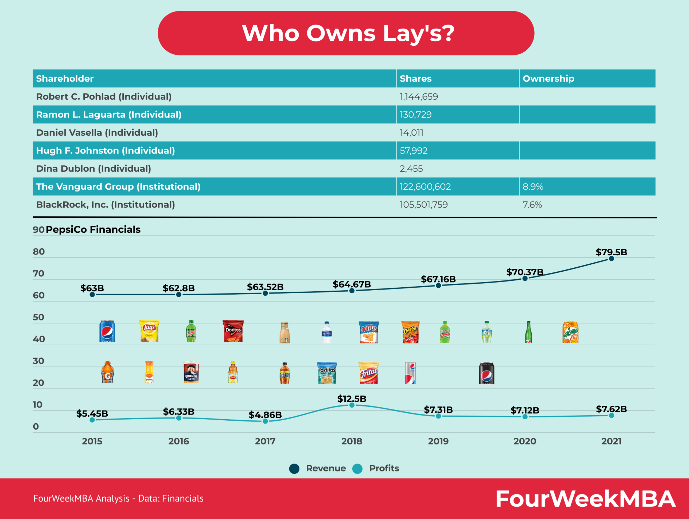

**Process Analysis**

1. **Potato Sourcing and Preparation**
   * Potato Sourcing  
     Lay's sources high-quality potatoes from top growing regions, ensuring freshness and flavor.
   * Careful Inspection  
     Each batch of potatoes is inspected for quality before processing.
   * Precise Cutting  
     The potatoes are thinly sliced for even frying and consistent crunch.
2. **Frying and Seasoning Process**
   * Perfect Frying  
     The chips are fried to a golden crisp using carefully controlled methods.
   * Signature Seasonings  
     A variety of seasonings are applied to create the signature Lay's taste.
   * Flavor Innovation  
     Lay's continually innovates, introducing new flavors to cater to changing consumer preferences.
3. **Packaging and Distribution**
   * Protective Packaging  
     The chips are packaged in airtight bags to preserve freshness.
   * Widespread Distribution  
     Lay's distributes its products across India, making them accessible in grocery stores, shops, and vending machines.
   * Sustainable Efforts  
     Lay's is exploring eco-friendly packaging and improving distribution efficiency to minimize environmental impact.

### Quality Assurance and Continuous Improvement

1. **Rigorous Testing**  
   Lay's conducts extensive testing throughout the production process to ensure high quality and safety.
2. **Customer Feedback**  
   Lay's values customer feedback and uses it to continuously improve products and processes.
3. **Sustainability Initiatives**  
   Lay's is committed to sustainability by reducing waste, conserving resources, and minimizing environmental impact.

**4.Administration Development in Lay’s**

Lay's, a globally recognized snack brand, has developed a robust administrative framework that underpins its extensive operations. From optimizing supply chains to fostering product innovation, Lay's administrative strategies enhance operational efficiency, ensuring the company's continued success in an ever-evolving market.



## 4.1 Key Initiatives in Administrative Optimization

### 4.1.1 Streamlined Processes



Lay's administrative team has embraced lean management principles to eliminate inefficiencies across its operations. By reducing waste and redundancy, the company has achieved faster turnaround times and enhanced productivity. These improvements allow Lay's to remain agile and responsive to changing market demands.

### 4.1.2 Data-Driven Insights

Lay’s relies on advanced analytics to inform decision-making processes, optimize resource allocation, and identify opportunities for continuous improvement. Data-driven insights help streamline operations, ensuring that the company remains competitive in a global market.

### 4.1.3 Innovation and Product Development

Investment in research and development (R&D) serves as the bedrock of Lay's administrative strategy, allowing the company to maintain a competitive edge in the global snack industry. Lay's R&D efforts are multifaceted, encompassing everything from the creation of new and exciting flavors to the formulation of healthier snack options that cater to the growing demand for nutritious alternatives. By continually exploring diverse ingredients and cutting-edge food technology, Lay's strives to deliver products that align with consumers' shifting preferences toward wellness and conscious eating habits.

In addition to product development, Lay's focuses on innovation in packaging, with an emphasis on eco-friendly solutions. The company has invested significant resources into developing packaging materials that are not only durable and effective in preserving the freshness of its products but also environmentally sustainable.

**5.Service Development at Lay's**

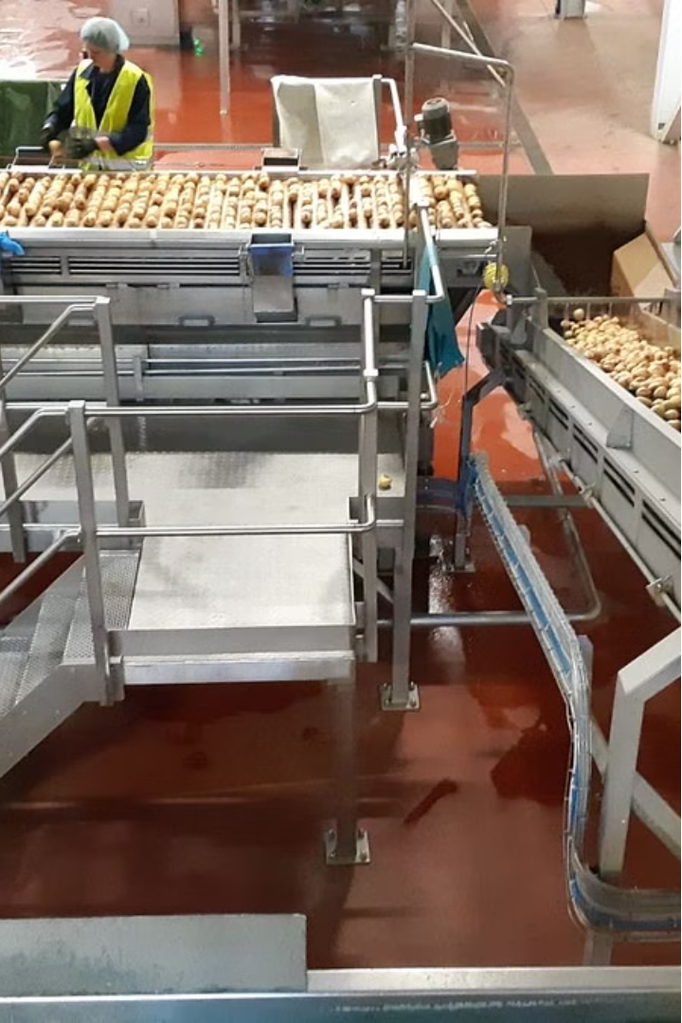

Service development is a critical component of Lay's strategy to maintain its position as a leading brand in the competitive snack food industry. As consumer preferences evolve and market dynamics shift, Lay's recognizes the importance of innovation and responsiveness in its product offerings. The company's service development process is designed to foster creativity, enhance customer engagement, and ensure that new products resonate with diverse consumer tastes.

At the heart of Lay's service development is a commitment to understanding and anticipating customer needs. By leveraging insights from extensive market research and customer feedback, Lay's is able to identify emerging trends and gaps in the market. This consumer-centric approach not only drives the creation of new flavors and formulations but also ensures that existing products are continuously refined to meet the expectations of snack enthusiasts.

Collaboration plays a vital role in Lay's service development efforts. The integration of cross-functional teams, including research and development (R&D), marketing, and culinary experts, allows for a holistic approach to product innovation. This collaborative environment fosters the exchange of ideas and insights, enabling Lay's to translate culinary inspirations and market trends into exciting new chip varieties.

Moreover, Lay's embraces an agile development process that allows for rapid prototyping and testing of new concepts. This flexibility enables the brand to respond swiftly to consumer feedback and market demands, ensuring that it remains at the forefront of the snack food industry. As Lay's continues to innovate, it also prioritizes sustainability and health-conscious options, reflecting a growing consumer desire for responsible and nutritious snack choices.

In this report, we will explore the various facets of Lay's service development strategy, highlighting its innovative practices, consumer engagement efforts, and commitment to sustainability. Through this examination, we aim to provide a comprehensive understanding of how Lay's successfully navigates the complexities of the snack food market while delighting its customers with new and exciting products.

**5.1.1 Actions involved**

1. **Commitment to Innovation:** Lay's has established itself as a leader in the snack food industry by prioritizing innovation in its product offerings. The company recognizes that consumer tastes are constantly evolving, and thus, it actively seeks to introduce new flavors and formulations. This commitment to innovation is not just about creating new products but also about enhancing existing ones to meet changing consumer preferences.
2. **Collaborative Approach with R&D:** The service development team at Lay's works in close collaboration with the research and development (R&D) department. This partnership is crucial for identifying emerging food trends and translating them into viable product concepts. By leveraging insights from R&D, Lay's can ensure that its new chip offerings are not only innovative but also feasible from a production standpoint. This collaboration allows for a seamless transition from concept to market-ready product.
3. **Culinary Inspiration from Global and Local Sources:** Lay's draws culinary inspiration from a wide array of sources, including global cuisines and local flavors. This diverse approach enables the brand to create unique chip varieties that appeal to a broad audience. For instance, Lay's may incorporate spices and flavors that are popular in specific regions, thereby catering to local tastes while also introducing international flavors that intrigue consumers. This strategy not only enhances product variety but also strengthens Lay's connection with its customer base.
4. **Utilizing Consumer Insights:** Understanding consumer preferences is at the heart of Lay's service development strategy. The company invests in extensive market research and actively seeks customer feedback to guide its innovation process. By analyzing consumer behavior and preferences, Lay's can identify gaps in the market and develop products that meet specific needs. This consumer-centric approach ensures that new products resonate with target audiences and enhances customer loyalty.
5. **Agile Development Process:** Lay's employs a highly iterative and agile development process for its product innovations. This means that the company can quickly prototype new chip concepts, conduct taste tests, and refine products based on feedback. The agility of this process allows Lay's to respond rapidly to market trends and consumer demands, ensuring that they remain competitive in a fast-paced industry. This iterative approach also minimizes the risk associated with launching new products, as Lay's can make adjustments before a full-scale launch.
6. **Focus on Healthier Snack Options:** In response to the growing trend of health-conscious eating, Lay's is increasingly investing in the development of healthier snack options. This includes exploring alternative ingredients, reducing sodium levels, and offering baked or reduced-fat varieties. By aligning its product development with health trends, Lay's not only meets consumer demand but also positions itself as a responsible brand that cares about the well-being of its customers.
7. **Sustainability in Service Development:** Lay's is also committed to sustainability in its service development initiatives. The company explores ways to reduce waste and minimize the environmental impact of its operations. This includes sourcing ingredients ethically and implementing sustainable practices throughout the supply chain. By integrating sustainability into its product development process, Lay's appeals to environmentally conscious consumers and enhances its brand reputation.
8. **Digital Marketing and Technology Integration:** To further enhance its service development, Lay's leverages digital marketing and technology. This includes using social media platforms to engage with consumers, gather feedback, and promote new products. Technology also plays a role in analyzing consumer data, which helps Lay's make informed decisions about product development and marketing strategies. By embracing digital tools, Lay's can enhance brand awareness and customer engagement effectively.

## 5.1.2.Operational Efficiency

Efficiency is key to Lay's success, and the company has implemented several measures to optimize production and distribution processes.

### Optimized Production

Lay's has streamlined its manufacturing processes to improve productivity while maintaining the highest quality standards. This ensures consistency across all its product varieties.

### Supply Chain Synergies

Lay's leverages a global logistics network to efficiently source ingredients and distribute products, reducing costs and minimizing the environmental impact of its operations.

### Sustainability Initiatives

The company is deeply committed to sustainability, with several initiatives aimed at reducing its carbon footprint and promoting environmentally responsible practices.

* **Sustainable Sourcing**: Lay's sources its potatoes from farms that prioritize sustainable agricultural practices, such as reducing water use and minimizing their environmental impact.
* **Packaging Reduction**: Lay's is working to reduce its packaging footprint by using recycled materials and exploring alternative packaging solutions.
* **Carbon Footprint Reduction**: Lay's is focused on optimizing energy use across its factories and adopting renewable energy sources to further reduce its carbon emissions.

## 5.1.3.Quality Assurance and Control



Lay's places a strong emphasis on quality assurance and control throughout its operations to maintain the highest standards.

* **Ingredient Testing**: Rigorous testing of raw materials ensures that only the best-quality ingredients are used in production.
* **Production Process Monitoring**: Lay’s closely monitors every stage of the production process to uphold its quality standards.
* **Product Inspection**: Thorough inspections of finished products ensure compliance with safety and quality benchmarks.
* **Consumer Feedback Monitoring**: Lay's actively gathers and analyzes consumer feedback to continually improve its products and processes.

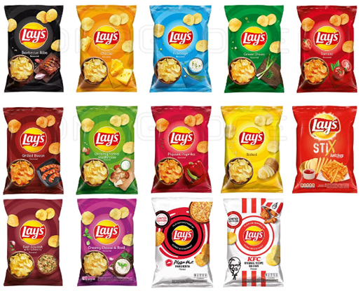

## Future Initiatives and Expansion Plans

Lay's is poised for continued growth, driven by a combination of innovation, global expansion, and sustainability.

* **New Product Development**: Lay's will continue to develop new flavors and varieties to satisfy the changing tastes of its customers.
* **Global Expansion**: Lay's is committed to expanding its presence in new markets, bringing its popular chips to an ever-wider audience.
* **Sustainability Initiatives**: As part of its long-term strategy, Lay's will continue to focus on reducing its environmental impact and supporting ethical sourcing practices.
* **Digital Marketing & Technology**: Lay's is increasingly leveraging digital marketing and technological innovations to enhance its brand presence, boost customer engagement, and drive sales.

**6.References**

1. Waller, Matthew A., and Sanjay Ahire. ‘Management Perception of the Link between Product Quality and Customers’ View of Product Quality’. *International Journal of Operations & Production Management*, vol. 16, no. 9, Sept. 1996, pp. 23–33. *DOI.org (Crossref)*, https://doi.org/10.1108/01443579610125561.
2. A Comparative Study of Consumer buying Behaviour towards Chips with reference to Bingo and Lays Mr. Devaraj B. Dodamani , Mr. Venkatesh Malali , Ms. Bhuvaneshwari D , Ms. Anita Naragund , Mr. Vikas Parvati
3. S.K., Dharani, and Praveen S.V. ‘A Study of Consumer Buying Behaviour towards Supermarkets’. International Journal of Research Publication and Reviews, vol. 4, no. 9, Sept. 2023,pp. 270–74. DOI.org (Crossref), https://doi.org/10.55248/gengpi.4.923.52401.
4. Khan Khayru, Rafadi, et al. ‘ANALYSIS OF PRODUCT PREFERENCE OF CHITATO AND LAYS POTATO CHIPS’. MARGINAL : JOURNAL OF MANAGEMENT, ACCOUNTING, GENERAL FINANCE AND INTERNATIONAL ECONOMIC ISSUES,vol.1,no.1,Dec.2021,pp.10–15.DOI.org(Crossref),<https://doi.org/10.55047/marginal.v1i1.7>.
5. Ouchon, P. B., and D. L. Pyle. ‘Studying Oil Absorption in Restructured Potato Chips’. Journal of Food Science, vol. 69, no. 3, Apr. 2004. DOI.org (Crossref), https://doi.org/10.1111/j.1365-2621.2004.tb13363.x.
6. Geier, Andrew, et al. ‘Red Potato Chips: Segmentation Cues Can Substantially Decrease Food Intake.’ *Health Psychology*, vol. 31, no. 3, 2012, pp. 398–401. *DOI.org (Crossref)*, <https://doi.org/10.1037/a0027221>.
7. Singh, Santhamma Sasankan R. G. ‘NATURE AND CAUSESE OF MALNUTRITION IN RURAL INDIA A Study of Betul in Madhya Pradesh’. Nursing Journal of India, vol. LXXX, no. 08, 1989, pp. 199–199. DOI.org (Crossref), <https://doi.org/10.48029/NJI.1989.LXXX801>.
8. Mavituna, Ferda. ‘From Recombinant Proteins to Potato Chips’. Food and Bioproducts Processing, vol. 75, no. 1, Mar. 1997, p. 1. DOI.org (Crossref), https://doi.org/10.1205/096030897531261.